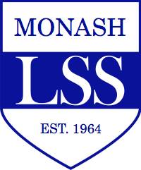
Monash Law Students’ Society Inc
ABN 26 196 034 117

Room G-14
15 Ancora Imparo Way lss@monashclubs.org
Monash University VIC 3800 www.monashlss.com

PROXY FORM
Monash Law Students’ Society Annual General Meeting
Held on Monday 16 September 2019 at 12:00pm
Location TBA, Monash University Clayton Campus

Name of member:
Name of nominated proxy:
Specific Instructions for proxy to follow (if applicable):

Signed:
Date:

Please note that this form must be submitted physically or electronically to Mia Steward, Secretary of the Monash Law Students’ Society, by no later than 12:00pm Friday 13 September 2019 to take effect. It can be emailed to secretary@monashlss.com or handed in to the LSS office.

